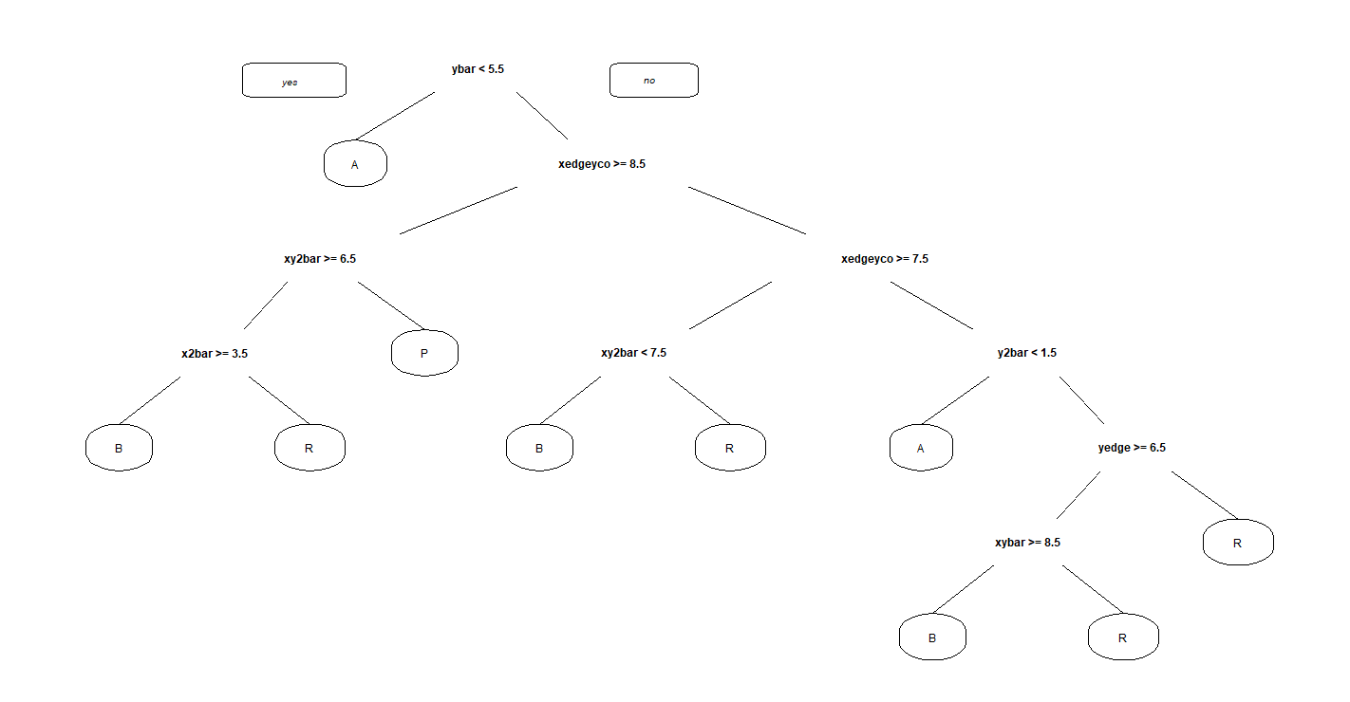

**Accuracy of Training Dataset**

predictCART1

A B P R

A 430 4 3 36

B 10 391 12 47

P 4 27 439 12

R 6 31 0 418

(430+391+439+418)/(4+3+36+10+12+47+4+27+12+6+31+0+430+391+439+418)

0.8973262

**Accuracy of Testing dataset**

predictCART2

A B P R

A 274 1 4 37

B 9 261 5 31

P 6 28 283 4

R 6 24 0 273

(274+261+283+273)/(1+4+37+9+5+31+6+28+4+6+24+0+274+261+283+273)

0.8756019

**Confusion Matrix and Statistics**

Reference

Prediction A B P R

A 274 9 6 6

B 1 261 28 24

P 4 5 283 0

R 37 31 4 273

**Overall Statistics**

Accuracy : 0.8756

95% CI : (0.856, 0.8934)

No Information Rate : 0.2576

P-Value [Acc > NIR] : < 2.2e-16

Kappa : 0.8342

Mcnemar's Test P-Value : 4.551e-09

Statistics by Class:

Class: A Class: B Class: P Class: R

Sensitivity 0.8671 0.8529 0.8816 0.9010

Specificity 0.9774 0.9436 0.9903 0.9236

Pos Pred Value 0.9288 0.8312 0.9692 0.7913

Neg Pred Value 0.9558 0.9517 0.9602 0.9667

Prevalence 0.2536 0.2456 0.2576 0.2432

Detection Rate 0.2199 0.2095 0.2271 0.2191

Detection Prevalence 0.2368 0.2520 0.2343 0.2769

Balanced Accuracy 0.9223 0.8983 0.9359 0.9123

**Random forest method Predictions**

Call:

randomForest(formula = letter ~ ., data = train2)

Type of random forest: classification

Number of trees: 500

No. of variables tried at each split: 4

OOB estimate of error rate: 1.28%

Confusion matrix:

A B P R class.error

A 471 1 0 1 0.004228330

B 0 455 0 5 0.010869565

P 1 2 479 0 0.006224066

R 0 14 0 441 0.030769231

**Checking the accuracy** of the model

predForest1<-predict(PredictForest1, newdata=Test, type = "class")

table(Test$letter,predForest1)

predForest1

A B P R

A 316 0 0 0

B 0 300 0 6

P 0 0 321 0

R 0 5 0 298

(316+300+321+298)/(6+5+316+300+321+298)

0.9911717

**Variable importance chart**

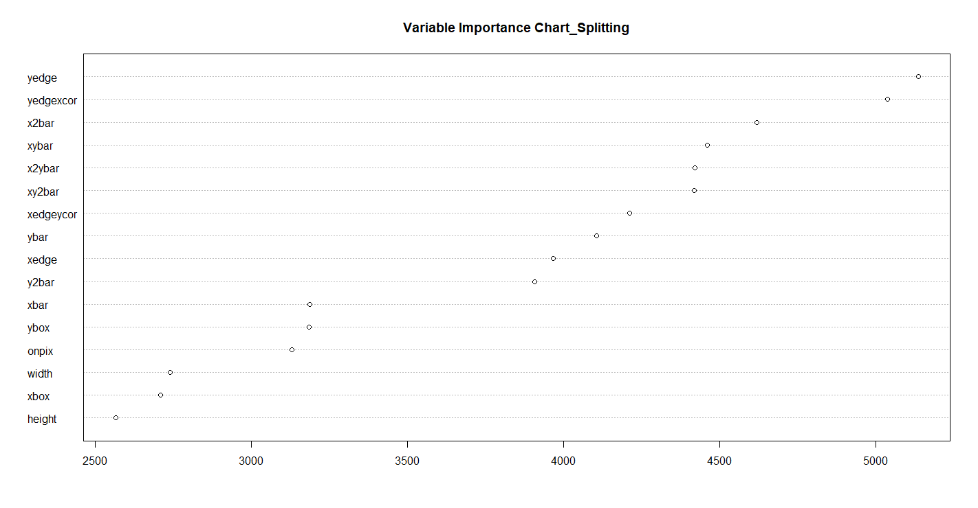

Here yedge is the most important variable as it had spitted most number of times

I**mpurity chart** shows that which variable is having the least impurities in it (gini)

so as considered as the most important variable acc to this chart

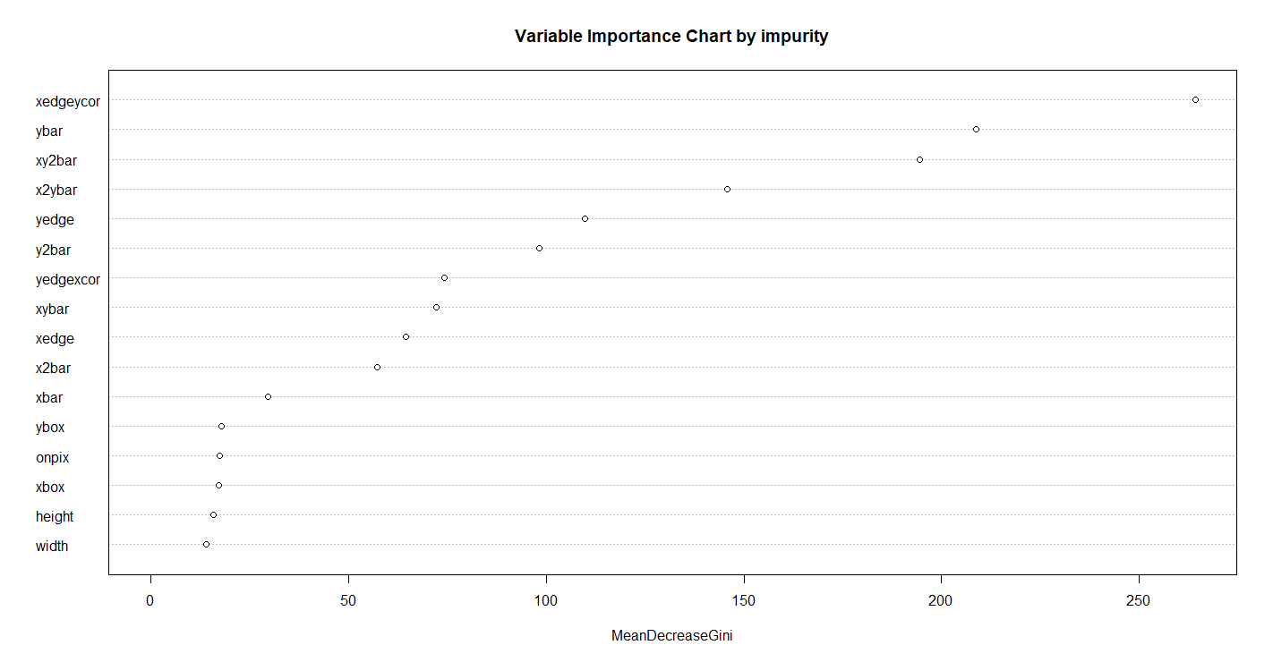

So here xedgeycor is most important in terms of impurity reduction